RECORDING REQUESTED BY )
AND WHEN RECORDED RETURN TO: )
)
River Pines Public Utility District )
22900 Canyon Avenue )
River Pines, CA 95675 )

Exempt from recording fee pursuant to Portion of A.P.N.s 014-091-009,
Government Code Sections 6103 014-091-023

GRANT OF EASEMENT
(APNs 014-091-009, 014-091-023)

THIS GRANT OF EASEMENT (“Easement Agreement”) is entered into as of this ____ day of __________, 2023 (the “Effective Date”), by and between harrison / lamb trust (“Grantor”), and the RIVER PINES PUBLIC UTILITY DISTRICT, a California special district (“Grantee” or “District”), with reference to the following:
- Grantor is the sole owner of certain real property commonly known as 22741 Circle Avenue, River Pines, County of Amador, State of California, APN 014-091-009, and legally described in Exhibit A attached hereto;
- Grantor is the sole owner of certain real property commonly known as 22739 Circle Avenue, River Pines, County of Amador, State of California, APN 014-091-023, and legally described in Exhibit B attached hereto;
- The real properties described in Exhibit A and Exhibit B are hereinafter referred to as the “Servient Estate”;
- Grantee is the sole owner of certain real property commonly known as 22711 Circle Avenue, River Pines, County of Amador, State of California, APN 014-091-022, and legally described in Exhibit C attached hereto, hereinafter referred to as the “Dominant Estate”;
- Grantor has permitted Grantee to use that certain portion of the Servient Estate as depicted in Exhibit D attached hereto (the “Easement Area”) for access to and from the Dominant Estate for many years; however, the grant of easement has never been recorded in the official records of Amador County; and
- By this Easement Agreement Grantor and Grantee are setting forth boundaries of the Easement Area and the terms and conditions of its use and maintenance as set forth below and providing for the recording of this Easement Agreement in the official records of Amador County.
NOW, THEREFORE, for good and sufficient consideration, receipt of which is hereby acknowledged, Grantee and Grantor covenant and agree as follows:
- Grant of Easement. Grantor hereby grants and conveys to the Grantee, its successors and assigns, for use by the Grantee, a perpetual easement and right-of-way through, in, over, above, under and across the Easement Area for motorized vehicle use, and those appurtenances and uses commonly associated therewith. Grantor agrees that it shall not construct or permit to be constructed, any building or any other permanent structure within the Easement Area or make or permit any permanent excavation to be made within the Easement Area. This is an easement appurtenant and is required to provide the owner of the Dominant Estate with access to a public right of way.
- Maintenance of the Easement Area. Grantor and Grantee agree to be jointly responsible for all costs of maintaining the Easement Area so long as this Easement Agreement is in effect. As of the date of this Easement Agreement neither party is aware of any maintenance that needs to be performed on the Easement Area.

In the future, if either Grantor or Grantee determines that there is a need for maintenance, the parties shall meet and confer in good faith to reasonably determine what level of maintenance needs to be done and who should best either perform or arrange for maintenance of the Easement Area. Any costs incurred by either party in maintaining the Easement Area shall be split on an equal basis between the two parties, no matter who does the maintenance work. In the event the parties to this Easement Agreement cannot reach an agreement regarding whether and how much maintenance is needed, if Grantee reasonably determines that the unmaintained state of the Easement Area interferes with its ability to maintain the facilities on Dominant Estate, Grantee retains the right to perform the work on its own. Grantee shall then have the right to pursue any legal or equitable remedies it has to seek contribution from Grantor for Grantor’s one half (1/2) of the maintenance costs, including, but not limited to, recording a lien against the Easement Area or any other remedies available in a court of law.

As of the date of this Easement Agreement, the Easement Agreement is paved with gravel and dirt. If Grantor ever decides to improve the level of paving to asphalt or some other surface besides gravel and dirt, Grantor agrees to be 100% responsible for any future maintenance of the Easement Area. The obligation of Grantor to take on full responsibility for future maintenance of the Easement Area does not diminish in any way Grantee’s right to use the Easement Area pursuant to the easement granted above.
- Damage to Servient Estate. Any damage to the Servient Estate or Easement Area resulting the District’s sole, active negligence or willful misconduct shall be repaired at District’s sole cost and expense. Any damage to the Servient Estate or Easement Area resulting from the Grantor’s negligence or willful misconduct shall be repaired at Grantor’s sole cost and expense.
- Nonexclusive Easement. The easement granted in this Easement Agreement is nonexclusive. Grantor retains the right to make any use of the Servient Estate, including the right to grant concurrent easements in the Servient Estate to third parties, that do not interfere with Grantee's free use and enjoyment of the Easement Area.
- Damage and Destruction. In the event of the damage or destruction of the Easement Area for reasons other than Grantor’s gross negligence or willful misconduct, the District shall restore the Easement Area to a safe condition. Should the Easement Area be damaged or destroyed solely due to the gross negligence or willful misconduct of the Grantor, the Grantor shall repair the Easement Area to its condition prior to such damage or destruction, at Grantor’s cost. Damage and destruction shall not terminate this Easement Agreement. The District or Grantor, as applicable, shall repair any damage as soon as reasonably possible.
- Term. This Easement Agreement shall commence on the date it is recorded in the official records of Amador County and shall terminate upon the recordation in the official records of Amador County of an agreement to terminate executed by the District with notary acknowledgement.
- General Provisions
  - No Public Dedication. Nothing in this Easement Agreement is intended or shall be construed to be a dedication to the public of any portion of the Grantor’s Servient Estate.
  - Breach Shall Not Permit Termination. It is expressly agreed that no breach of this Easement Agreement shall entitle Grantor or Grantee to cancel, rescind or otherwise terminate this Easement Agreement, but such limitation shall not affect, in any manner, any other right or remedies which the parties may have hereunder by reason of any breach of this Easement Agreement.
  - Binding on Successors. This Easement Agreement shall be binding on the successors and assigns of the parties.
  - Remedies. In addition to all other remedies allowed by law, the parties, their successors and assigns, shall have the right to seek injunctive relief for the enforcement of the terms and conditions of this Easement Agreement.
  - No Third-Party Beneficiaries. Nothing in this Easement Agreement, express or implied, is intended to confer upon any person, other than the parties and their respective successors and assigns, any rights or remedies under or by reason of this Easement Agreement.
  - Amendments. This Easement Agreement may not be modified or amended except by a written instrument executed by all parties or their successors in interest and recorded in the Official Records.
  - Negation of Agency. The District and Grantor acknowledge that, in entering and performing under this Easement Agreement, each is acting independently and not as an agent of the other in any respect. Nothing contained herein shall be construed to make the District and Grantor joint venturers or partners or to establish a relationship of employer and employee between them.
  - Severability. If any part of this Easement Agreement is declared invalid for any reason, such invalidity shall not affect the validity of the remainder of the Easement Agreement.
  - Entire Agreement. This Easement Agreement represents the entire agreement between the parties and supersedes all prior agreements and understandings, whether oral or written, between them with respect to the matters contained in this Easement Agreement. Each party enters into this Easement Agreement based solely upon the representations set forth herein and upon each party’s own independent investigation of any and all facts such party deems material. This Easement Agreement shall be construed as a whole, according to its fair meaning, and not strictly for or against either of the parties hereto.

[Signatures on following page]

IN WITNESS WHEREOF, the Grantee and the Grantor have executed this Easement Agreement as of the Effective Date:

“DISTRICT”  River Pines Public Utility District  AUTHORIZED SIGNATORY:  Signature:  Printed:  Title:  Date:  ATTEST:  Signature:  Printed:  Title:  Date:  APPROVED AS TO FORM:  Signature:  Printed:  Title:  Date: | “GRANTOR”  HARRISON / LAMB TRUST  AUTHORIZED SIGNATORY:  Signature:  Printed:  Title:  Date:  AUTHORIZED SIGNATORY:  Signature:  Printed:  Title:  Date:

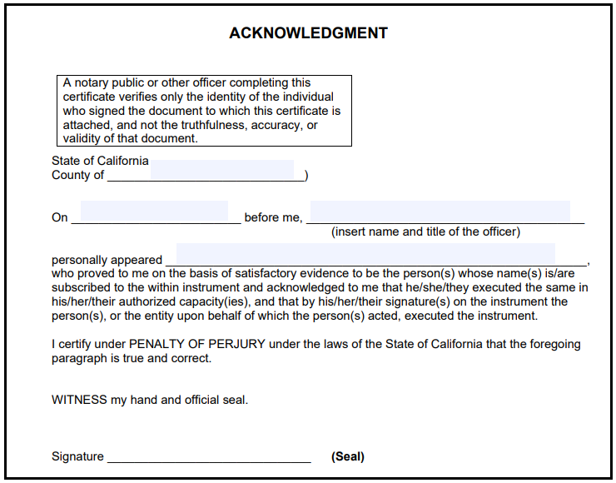

Certificate of Acceptance

This is to certify that the interest in certain real property described in Exhibit A and Exhibit B, and depicted in Exhibit D, and conveyed by that deed, grant or other instrument dated _______________, 2023, from HARRISON / LAMB TRUST, and which is attached hereto, is hereby accepted by the undersigned agent on behalf of the River Pines Public Utility District, and the District hereby consents to the recordation thereof by its duly authorized agent.

Dated: ______________, 2023

ACCEPTANCE:

Candi Bingham, General Manager

ATTEST:

__________________________
[NAME], [TITLE]
EXHIBIT A

LEGAL DESCRIPTION OF APN 014-091-009

(behind this page)

EXHIBIT B

LEGAL DESCRIPTION OF APN 014-091-023

(behind this page)

EXHIBIT C

LEGAL DESCRIPTION OF APN 014-091-022

(behind this page)

EXHIBIT D

DEPICTION OF THE EASEMENT AREA

(behind this page)

